Temperature fields in the tropical tropopause transition layer

XueLong Zhou, Marvin A. Geller, and Minghua Zhang

Institute for Terrestrial and Planetary Atmospheres
State University of New York at Stony Brook, NY 11794

Corresponding author and email address:
XueLong Zhou xzhou@notes.cc.sunysb.edu

Abstract
There has been increasing recognition of the role of the tropical tropopause layer (TTL) in determining stratospheric water vapor concentrations – the TTL being a layer of transition between air showing tropospheric properties below and stratospheric properties above. In this study, we investigated the spatial structure of temperatures in the TTL. A dehydration index based on the atmospheric region with temperatures colder than a reference temperature was defined to examine the TTL temperature structure and possible influences on stratospheric water vapor. The results indicate that dehydration regions with cold temperatures (e. g., <190 K) occur mainly over the western Pacific and are about 1.5-2 km in depth during Northern Hemispheric winter. Primitive examination of the tropical upwelling velocity and zonal winds implies that NH winter conditions might dominate annual mean dehydration. The dehydration index is mainly dependent on the annual cycle of the TTL temperatures, and is strongly affected by interannual variations associated with the quasi-biennial oscillation (QBO) and El Niño-Southern Oscillation (ENSO). Dehydration regions with extremely cold temperatures and large sizes occur when cold temperature anomalies associated with the QBO arrive at the TTL in wintertime while the TTL is at the coldest phase of the annual cycle and under La Niña conditions. La Niña events have a more dramatic influence on the dehydration index than El Niño events. Interesting long-time scale variations in the dehydration index have been found, but these remain to be verified by comparison with sounding observations.
1. Introduction

Mass exchange between the troposphere and the stratosphere is dominated by the mean meridional circulation, with upwelling in the Tropics and downward motion at higher latitudes (Holton et al., 1995; and references therein). The fact that observed concentration of stratospheric water vapor is much smaller than the saturation mixing ratio of water vapor at zonally averaged tropical temperatures led Newell and Gould-Stewart (1981) to propose the “stratospheric fountain” hypothesis. This suggests that tropospheric air enters the stratosphere across the tropical tropopause over the Western Pacific, and preferentially in the Northern Hemispheric (NH) winter. However, some studies indicated that the vertical velocity near the tropopause over the Western Pacific is likely downward instead of upward (Sherwood, 2000). Thus, it is more appropriate to call the cold TTL area over the Western Pacific the “cold trap” for air entering the stratosphere (Holton and Gettelman, 2001). In this paper, “dehydration regions” were used instead of the term of “cold trap” when referring to cold TTL areas in tropical longitudes including, but not limited to, the Western Pacific.

During the past few years, there has been increasing recognition of the role of the tropical tropopause layer (TTL) in determining stratospheric water vapor – the TTL being a layer of transition between air showing tropospheric properties below and stratospheric properties above (Sherwood and Dessler, 2001; Holton and Gettelman, 2001). In this study, we investigated the spatial and temporal structure of temperatures near the tropical tropopause. Since we were considering the dehydration to stratospheric water vapor concentrations, we defined an index “dehydration volume (DV)” based on the atmospheric region with temperatures colder than a reference temperature, to examine the TTL temperature structure and possible influence on stratospheric water vapor. This index reflects the degree of coldness of the tropical TTL. We found that the DV during the 1982-1983 winter was very small and the DV in the winter 1984-1985 was very large. Previous studies indicated that the tropical tropopause is affected by the stratospheric quasi-biennial oscillation (QBO) and the tropospheric El Niño-Southern Oscillation (ENSO) (Randel et al. 2000; Zhou et al. 2001a). In this study, we investigated the combined effects of the QBO and ENSO, as manifested in the temperature field near the tropical tropopause.

This paper was arranged as follows. Section 2 briefly describes the definition of the DV and the data sets used in this study. Section 3 presents horizontal and vertical distributions of multi-year mean temperature fields near the tropopause. The time series of the DV index is given in section 4. In this section, the underlying physical circumstances for two extreme cases were investigated. Section 5 is the discussion and summary section.

2. Data sets and definition of the “dehydration volume”

The principal data set used in this study is the ECMWF reanalyses (1979-1993, hereafter referred as ERA-15). Stratospheric zonal wind shear at 50 hPa over Singapore and sea surface temperature anomaly in the Niño-3.4 region (5°S-5°N, 120°W-170°W) were used as indices for the QBO and the ENSO, respectively.

To investigate variations in the coldness of the tropical TTL, an index (“dehydration volume [DV]”) was defined as the volume of air with temperatures below a reference temperature in the tropical region between 15-20 km and 20°S-20°N. The grid version of the ERA-15 has 17 standard pressure surfaces and a horizontal resolution of 2.5°x2.5°. Temperatures every 100 m in the vertical direction between 15-20 km and 20°S-20°N were obtained using cubic spline fitting (refer to Zhou et al. 2001b for more information). Comparison with sounding data indicated that the ERA-15 tracked tropopause variations very well except that the ERA-15 overestimated the tropical cold point tropopause temperatures by approximately 2 K (Zhou et al. 2001a, 2001b). The reference temperature adopted is 192 K. Considering the warm bias in the ERA-15, we strived for an actual reference temperature of approximately 190 K. It should be emphasized that the warm bias of temperature in the ERA-15 was not adjusted in the temperature sections that are shown in this paper. Assuming a pressure of 100 hPa, the real reference temperature (190 K) corresponds to a saturation mixing ratio of water vapor with respect to ice of approximately 3.26 ppmv. The entry value of water vapor mixing ratio at the tropical tropopause is about 3 to 4.1 ppmv based on multiple instrument observations, corresponding to a 100 hPa entry-level temperature range of 189.7 K to 191.4 K (SPARC, 2000). The reference temperature used in DV calculation is close to the lower value of this temperature range.

3. Mean temperature field near the tropical tropopause

Figure 1 shows average horizontal sections of ERA-15 based temperatures at 17 km and vertical sections of temperatures over the equator. The areas with temperatures below the reference temperature (192 K) are shaded. It is seen that cold temperatures occur over the Western Pacific in NH winter. In NH summer, tropopause temperatures are about 4 K warmer, and the tropopause is about 0.5 km lower than in winter. This is consistent with previous results (e.g., Newell and Gould-Stewart, 1981). Figure 1 suggests that the “cold trap” not only is extensive horizontally but also is thick (about 1.5-2 km). Upwelling velocities near the tropical tropopause are about 0.1-0.2 mm/s in July and 0.2-0.4 mm/s in January (Rosenlof, 1995; Mote et al. 1998). Thus, it takes about 3-6 months for an air parcel to transverse a depth of 1.5 km near the tropopause at the typical summertime upwelling velocity and about 1-3 months at the typical wintertime upwelling velocity. It also takes about 1-2 months for an air parcel to travel once around the Earth along the equator, assuming a zonal wind of 5-10 m/s. Because of the fast horizontal motion and slow vertical motion, air parcels which cross the lower boundary of the TTL at longitudes other than the Western Pacific have a large probability of being dehydrated by the “cold trap” before they enter the stratosphere across the upper boundary of the TTL. Because summertime upwelling velocities are much slower than wintertime upwelling velocities, many air parcels which cross the lower boundary of the TTL in summer are dehydrated in the “cold trap” in winter before they enter the stratosphere. Of course, not all summertime air parcels are dehydrated in the wintertime “cold trap”. Otherwise, the “tape recorder” in stratospheric water vapor would not have been observed (Mote et al. 1996). The above speculation is a first order approximation. Trajectory calculation backed by accurate upwelling velocity and horizontal wind is needed to prove it.

Values for the DV index, based on monthly mean temperatures averaged over the period of ERA-15 (1979-1993), were plotted in Figure 2. It can be seen that large DV values occur in NH winter, with the largest value 63.07 million km³ in January. During NH summer, the averaged DV for these years is zero due to the warm tropopause layer temperatures.

4. DV variations and two extreme cases

Figure 3 shows the time series of the DV derived from ERA-15. The DV for the Western Pacific (120ºE-210ºE) was also plotted. The DV had large values during the NH winter seasons and were either virtually or identically zero during the NH summer seasons. This is consistent with previous results indicating that the tropical tropopause is much warmer in NH summer than in winter. For most winters, the DV index for the entire Tropics was only slightly larger than the DV value for the Western Pacific. This is consistent with previous results indicating that the coldest tropopause regions are over the Western Pacific in NH winter (Newell and Gould-Stewart, 1981). However, there were large differences between the DV values for the entire Tropics and the Western Pacific for some winters, especially the 1984-1985 winter. The DV for the entire tropics was about 280 million km³ and the DV for the Western Pacific was about 100 million km³ during the 1984-1985 winter. Both values are much larger than the multi-year mean DV value in January (63.07 million km³). Large difference between the DV values for the entire tropics and the Western Pacific indicates that during the 1984-1985 winter the “dehydration regions” had a broad longitudinal extension beyond the Western Pacific. For another extreme case, the DV in 1982-1983 was very small for both the entire tropics and the Western Pacific. The ERA-15 based DV calculation is consistent with sounding observations. The tropical cold-point tropopause (CPT) temperature averaged over the entire Tropics using operational sounding observations indicated that the 1984-1985 winter was one of coldest winters and that the 1982-1983 winter was one of warmest winters during the 1973-1998 period (see figure 3 of Zhou et al. 2001b).

Figure 4 shows the horizontal sections at 17.5 km and vertical sections over the equator for the two winters: 1982-1983 and 1984-1985. The 17.5 km level was selected because it is close to the average altitude of the tropical CPT in NH winter. During the 1982-1983 winter, the cold area with temperatures below the reference temperature (192K) covered a small area over the subtropical Eastern Pacific to the tropical Atlantic (Figure 4a) and was relatively thin in its vertical extent (Figure 4b). During the 1984-1985 winter, the TTL was cold throughout the entire tropics, with the coldest area below 188 K (or below 186 K after the warm bias was allowed for) near the dateline (Figure 4c). The cold area was relatively thicker (Figure 4d), and the level of the CPT was about 0.5 km higher than in 1982-1983. The SPARC Water Vapor Assessment indicated that the entry value of water vapor at the tropical tropopause is about 3 to 4.1 ppmv, corresponding to a 100 hPa entry-level temperature range of 189.7 K to 191.4 K (SPARC, 2000). Monthly mean CPT temperatures at almost any longitude in the 1984-1985 winter were able to dehydrate air parcels entering the stratosphere to the lower range of the estimated entry value of water vapor.

Figure 5a shows the differences of temperature between the two winters at 17.5 km. Temperature differences greater than 4 K occurred at most longitudes. Note that an El Niño occurred in 1982-1983, and a La Niña occurred in 1984-1985. The horizontal section of the temperature differences is dominated by the ENSO signature in temperatures near the tropopause (Zhou et al. 2001a). The ENSO signature at the tropical CPT shows features of a north-south dumbbell, a west-east dipole and a cold/warm core between the dipole (Zhou et al. 2001a). During El Niño periods, the tropopause has cold anomalies over the Eastern Pacific and warm anomalies over the Western Pacific. However, the tropopause over the Eastern Pacific is usually 4 K warmer than the tropopause over the Western Pacific (Figure 1a). This horizontal contrast of temperatures near the tropopause is larger than the magnitude of the cold temperature anomalies associated with El Niño over the Eastern Pacific. Therefore, the cold TTL temperature anomalies associated with El Niño events over the Eastern Pacific are not able to increase the DV index. The warm tropopause temperature anomalies associated with El Niño over the Western Pacific warms this climatologically cold area. As a result, El Niño generally results in a smaller DV value. In contrast, during La Niña events, the warm TTL temperature anomalies over the Eastern Pacific do not significantly affect the DV because climatologically this area is already warmer than the defined temperature threshold. Cold temperature anomalies over the Western Pacific (the cold “dumbbell” in the subtropics and the cold core between the east-west “dipole” along the equator, see figure 8b of Zhou 2001a) make this climatologically cold region even colder. This results in the “cold trap” covering a wider area and being thicker in the vertical. As a result, the DV index increases during La Niña events. Thus, positive (negative) SSTA in the Niño 3.4 region generally represent negative (positive) contribution of ENSO events to the DV index.

The vertical section of the temperature differences shows cold and warm downward propagating features along the equator (Figure 5b). Figure 6 shows the temporal evolution of temperature anomalies at altitudes between 10-25 km over the equator. The anomaly here was defined as zonal monthly temperature at each altitude minus its annual cycle. The dominant feature of Figure 6 is alternating positive and negative temperature anomalies propagating downward from the stratosphere to the TTL. QBO warm temperature anomalies are associated with westerly wind shears, and QBO cold anomalies are associated with easterly wind shears (Plumb and Bell, 1982). It takes about 4-7 months for the wind shear or QBO temperature anomaly to reach the tropopause. Accordingly, a 6 months time lag adjustment for the QBO wind shear time series was made in Figure 7, which shows the time series for normalized sea surface temperature anomalies (SSTA) in the Niño-3.4 region and stratospheric wind shear at 50 hPa. The cold area (e.g., T < 192 K) is located in the altitude range of 16-18 km (Figure 1c) rather than at a fixed altitude. Also, westerly wind shear propagates downward faster than the easterly shear (Naujokat, 1986). Thus, the 6 month adjustment for time lag is only a rough estimate. However, this does not affect the following interpretation in a significant way.

The QBO wind shear in Figure 7 is hatched with horizontal lines and the SSTA index was hatched with vertical lines. The period with positive (negative) contributions of either the QBO wind shear or the SSTA to the tropopause temperatures (the DV index) is indicated in red, and negative (positive) contribution to the tropopause temperatures (the DV index) in blue. A westerly wind shear coupled with a warm Niño-3.4 SSTA anomaly (i. e., El Niño) was present during the 1982-1983 winter. Both factors tend to reduce the DV indedx. An easterly wind shear coupled with a cold Niño-3.4 SSTA anomaly (i. e., La Niña) occur during the 1984-1985 winter. Both factors tend to increase the DV index, resulting in extremely large DV values. Thus, the extremely large DV in the 1984-1985 winter and the extremely small DV in the 1982-1983 winter were caused by temperature anomalies associated with both the QBO and ENSO.

Figure 8 shows the DV index covering a longer period. The NCEP reanalysis (NCEP-R) based DV used a reference temperature of 194 K, taking account the warm bias of tropopause temperatures in the NCEP-R (Randel et al., 2000; Zhou et al., 2001a; SPARC 2002). The NCEP-R based DV was consistent with the ERA-15 based DV during the available period of the ERA-15. The NCEP-R based DV indicates a change of the DV index pattern after the early 1990s. The wintertime DV increased and there were noticeable DV values in summertime whereas these were absent before this time. The cause for this remarkable change in DV, if real, is not obvious. According to the time series for the QBO and ENSO (Figure 7), large (small) DV values were expected to have occurred in the 1996-1997 (1997-1998) winter. However, this did not show up clearly in the NCEP-R based DV calculations (Figure 8). Sounding observations indicated that the CPT in the 1996-1997 winter and the CPT in the 1997-1998 winter were indeed colder and warmer, comparable to the 1984-1985 and 1982-1983 winters respectively (figure 2 of Zhou et al., 2001a and figure 3 of Zhou et al., 2001b). This supports our previous conclusion that coupling between the QBO and the ENSO is responsible for extremely large or small DV values. This also indicates that caution should be applied to the interesting long term variation of the NCEP-R based DV values.

5. Discussion and summary

In this paper, the temperature field near the tropical tropopause and the volume of extremely cold regions were studied. Results indicated that temperatures near the tropical tropopause are much warmer during NH summer than in winter. According to sounding observations, cold tropopause temperatures may fall below the reference temperature (190 K) in the summer; however, its occurrence frequency is much less than in winter. Based on monthly mean data, summertime DV is virtually zero for a stratospheric dehydration reference temperature (e.g., 190 K, or 192 K before the ERA-15 warm bias adjustment was made). In the winter, the “cold trap” is over the Western Pacific and has a thickness of about 1.5-2.0 km in the vertical. Given the small upwelling velocity of the meridional circulation and fast zonal motion near the tropical tropopause, air parcels which enter the TTL across its lower boundary at longitudes other than the Western Pacific are likely dehydrated by the “cold trap” over the Western Pacific before they enter the stratosphere across the upper boundary of the TTL. Also, many of the air parcels which enter the TTL in the summer are dehydrated by the “cold trap” in winter. The latter suggests that wintertime tropopause temperatures are more important than summertime tropopause temperatures for dehydration to stratospheric water vapor mixing ratios.

To first order, the QBO signature in the tropopause temperatures is zonally symmetric; however, the ENSO signature is zonally asymmetric (Randel et al. 2000; Zhou et al. 2001a). It has a north-south dumbbell, west-east dipole pattern and an area of maximum anomalies between the west-east dipole (Zhou et al., 2001a). If the cold anomalies associated with the QBO arrive at the tropopause in summer, the QBO will not make a significant contribution to the DV because the background tropopause temperatures (i.e., mean temperatures in the summer) are very warm. The summer of 1992 is an example of this. If the cold anomalies associated with the QBO reach tropopause levels in winter when the annual cycle of tropopause temperatures is at its coldest phase, the coupling between cold QBO anomalies and the annual cycle of the tropopause temperatures enhance the DV. On the other hand, if warmer QBO anomalies reach the TTL in winter, it will reduce DV values at that time.

The contribution of ENSO events to the DV variations can be examined by looking at the degree of zonal asymmetry of tropopause temperatures. The Eastern Pacific normally is about 4 K warmer than the Western Pacific in winter. When winter is during an El Niño period, the El Niño makes the Eastern Pacific a little colder and the Western Pacific a little warmer, reducing the zonal temperature contrast. This leads to a low DV. On the other hand, when winter is during a La Niña period, the maximum negative equatorial anomalies over the Western to Central Pacific (around 150-160°E) and the associated cold dumbbell-shaped anomalies (around 100-120°E) make the tropopause over the subtropical Western Pacific colder, resulting in a larger area of the “cold trap”. Thus, La Niña events provide a greater and colder region over which dehydration can occur than exists during El Niño events.

Two extreme cases were investigated in this paper. The small DV in the 1982-1983 winter was caused by the arrival of both warm QBO and El Niño temperature anomalies at CPT altitudes. The extremely large DV in the 1984-1985 winter was due to the additive effects of the cold QBO phase and La Niña related temperature anomalies with the cold phase of the annual temperature cycle. Large DV and small DV values were expected during the 1996-1997 and 1997-1998 winters, respectively. Sounding observations show supportive evidence for this. However, the ERA-15 does not cover these years, and the NCEP-R does not show the expected features.

Heavy aerosol load near the tropical tropopause makes the tropopause warmer and leads to smaller DV values (e.g. Angell, 1993; Randel et al. 2000). The tropical tropopause became warmer after the El Chichon volcanic eruption in 1982; however, the tropical tropopause did not show large warm anomalies after the Mt. Pinatobu eruption in 1991 (figure 3 of Zhou et al., 2001b). This difference might be caused by different phases of the QBO. After the El Chichon eruption, warm temperature anomalies associated with the QBO arrived at tropopause levels and enhanced the warming at the tropical tropopause. However, cold temperature anomalies associated with the QBO arrived at the tropopause after the eruption of Mt. Pinatubo, offsetting the warming aerosol effect. The observed cooling trend of tropical tropopause temperatures also offset the warming effect of the eruption of Mt. Pinatobu. El Chichon eruption contributed to the extremely small DV value in the 1982-1983 winter, but it is not known how important the volcanic eruption is to the DV index compared with the QBO influence. This is worth further investigation; however, it is beyond the scope of this paper.

Multiple processes affect the tropical tropopause, including its annual cycle, the QBO, ENSO, volcanic eruptions, trends, etc. The potential contribution of any of these processes might be studied by neglecting the other processes or holding them unchanged (e. g., Geller et al., 2002; Joshi and Shine, 2003). Due to the strong non-linearity of the Clausius-Clapeyron equation, however, a small anomaly in tropical tropopause temperatures, regardless of what process causes it, results in a significant change in the saturation water vapor mixing ratio. The net anomaly of contributions from multiple sources does not necessarily behave in the same way of any of the processes acting alone due to the enhancement and/or cancellation among the processes. The entry value of water vapor mixing ratio across the tropical tropopause (and thus the trend of stratospheric water vapor) depends on the temperature annual cycle and the net anomaly. The two extreme cases investigated in this paper show that coupling between the QBO and ENSO in NH winters (when the tropical tropopause is in the cold phase of its annual cycle) may change temperature fields near the tropical tropopause dramatically and result in extremely large or small DV values. These extremely large or small DV values should have been “recorded” in stratospheric water vapor. This needs further investigation.

In summary, the “cold trap” over the Western Pacific has a thickness about 1.5-2.0 km in NH winter. Wintertime tropopause temperatures are more important than summertime tropopause temperature for stratospheric dehydration, given slow tropical upwelling. An index in determining the yearly averaged entry water vapor mixing ratio, referred to here as the “dehydration volume”, is defined to reflect the three-dimensional extent of extremely cold tropopause temperatures. Cold QBO anomalies, coupled with the cold phase of the annual cycle in tropopause temperatures, enhance the DV index. In controlling the dehydration of tropospheric air to stratospheric water vapor mixing ratios, La Niña events have stronger potential than El Niño events. “Dehydration regions” with extremely cold temperatures and large sizes occur when cold temperature anomalies associated with the QBO arrive at the TTL in wintertime when the TTL is at the coldest phase of the annual cycle under La Niña conditions.

Acknowledgements. This work was supported by NASA grant NAS 022490 to SUNY at Stony Brook.

References

- Angell, J. K., 1993: Comparison of stratospheric warming following El Chichon, and Pinatubo volcanic eruptions, Geophys. Res, Lett., 20, 715-718.
- Geller, M. A., X.-L. Zhou and M. Zhang, 2002: Simulations of the interannual variability of stratospheric water vapor, J. Atmos. Sci., 59, 1076-1085.
- Holton, J. R., P. H. Haynes, M. E. McIntyre, A. R. Douglass, R. B. Rood, and L. Pfister, 1995: Stratosphere-troposphere exchange, Rev. Geophys., 33, 405-439.
- Holton, J. R., and A. Gettelman, 2001: Horizontal transport and the dehydration of the stratosphere. Geophys. Res. Lett., 28, 2799-2802.
- Joshi, M. and K. P. Shine, 2003: A GCM study of volcanic eruptions as a case of increased stratospheric water vapor, J. Climate, submitted.
- Mote, P. W., K. H. Rosenlof, M. E. McIntyre, E. S. Carr, J. C. Gille, J. R. Holton, J. S. Kinnersley, H. C. Pumphrey, J. M. Russell III, and J. W. Waters, 1996: An atmospheric tape recorder: the imprint of tropical tropopause temperatures on stratospheric water vapor, J. Geophys. Res., 101, 3989-4006.
- Mote, P. W., T. J. Dunkerton, M. E. McIntyre, E. A. Ray, P. H. Haynes, and J. M. Russell III, 1998: Vertical velocity, vertical diffusion, and dilution by midlatitude air in the tropical lower stratosphere, J. Geophys. Res., 103, 8651-8666.
- Naujokat, B. 1986: An update of the observed quasi-biennial oscillation of the stratospheric winds over the Tropics, J. Atmos. Sci., 43, 1873-1877.
- Newell, R. E. and S. Gould-Stewart, 1981: A stratospheric drain, J. Atmos. Sci., 38, 2789-2795.
- Plumb, R. A. and R. C. Bell, 1982: A model of the quasi-biennial oscillation on an equatorial beta-plane, Quart. J. Roy. Meteor. Soc., 108, 335-352.
- Ramaswamy, V. M-L. Chanin, J. Angell, J. Barnett, D. Gaffen, M. Gelman, P. Keckhut, Y. Koshelkov, K. Labitzke, J-J. R. Lin, A. O’Neill, J. Nash, W. Randel, R. Rood, K. Shine, M. Shiotani, and R. Swinbank, 2001: Stratospheric temperature trends: Observations and model simulations. Revs. Geophys. 39, 71-122.
- Randel, W. J., F. Wu and D. J. Gaffen, 2000: Low frequency variations of the tropical tropopause from NCEP reanalyses, J. Geophy. Res., 105, 15,509-15,523.
- Rosenlof, K. H., 1995: Seasonal cycle of the residual mean meridional circulation in the stratosphere, J. Geophys. Res., 100, 5173-5191.
- Sherwood, S. C., 2000: A stratospheric “drain” over the maritime continent, Geophys. Res. Lett., 27, 677-680.
- Sherwood, S. C. and A. E. Dessler, 2001: A model for transport across the tropical tropopause, J. Atmos. Sci., 58, 765-779.
- SPARC, 2000: SPARC assessment of upper tropospheric and stratospheric water vapor, Eds.: D. Kley, J. M. Russell III and C. Phillips, WMO/TD No. 1043.
- SPARC 2002: SPARC intercomparison of middle atmospheric climatologies, Eds.: W. Randel, M.-L. Chanin and C. Michaut, WMO/TD No. 1142.
- Zhou, X.-L., 2000: The tropical cold point tropopause and stratospheric water vapor, Ph.D. dissertation, State University of New York at Stony Brook, 121 pp.
- Zhou, X.-L., M. A. Geller and M. Zhang, 2001a: Tropical cold point tropopause characteristics derived from ECMWF reanalysis and soundings, J. Climate, 14, 1823-1838.
- Zhou, X.-L., M. A. Geller and M. Zhang, 2001b: Cooling trend of the tropical cold point tropopause temperatures and its implications, J. Geophys. Res., 106, 1511-1522.

Figure captions

Figure 1. Sections of temperatures near the tropical tropopause in January and July averaged over the ERA-15 available period (1979-1993). (a) Horizontal section at 17 km in January; (b) similar to (a), but for July; (c) vertical section over the equator in January; (d) similar to (c), but for July. Areas with temperature below 192 K are shaded.

Figure 2. The annual cycle of dehydration volume (10⁶ km³) based on the ERA-15. The DV is defined as the volume of air with temperatures below a reference temperature in the tropical region between 15-20 km and 20°S-20°N.

Figure 3. Dehydration volume (DV) based on the ERA-15 monthly mean temperatures. The blue curve is the DV for the entire Tropics and the red curve is for the western Pacific (120ºE-210ºE).

Figure 4. Horizontal sections at 17.5 km and vertical sections over the equator of the TTL temperatures in two extreme cases. (a) horizontal section for January 1983; (b) vertical section for January 1983; (c) horizontal section for January 1985; and (d) vertical section for January 1985.

Figure 5. Horizontal (a) and vertical (b) sections of the temperature difference between the 1984-1985 and 1982-1983 winters (December, January and February, and the 1984-1985 winter minus the 1982-1983 winter).

Figure 6. Evolution of temperature anomalies over the equator. The anomalies were defined as zonal mean temperatures minus their annual cycles at each altitude. The ticks along the horizontal axis correspond to Januaries.

Figure 7. Normalized time series of stratospheric wind shear at 50 hPa over Singapore and sea surface temperature anomalies in the Niño3.4 region. Areas enclosed by the wind shear curve were hatched with horizontal solid lines and areas enclosed by the SSTA curve were hatched by vertical solid line. Red was used for positive contribution to the DV index and blue was used for negative contributions.

Figure 8. Dehydration volume based on the ERA-15 (blue curve) and the NCEP reanalysis (red curve).
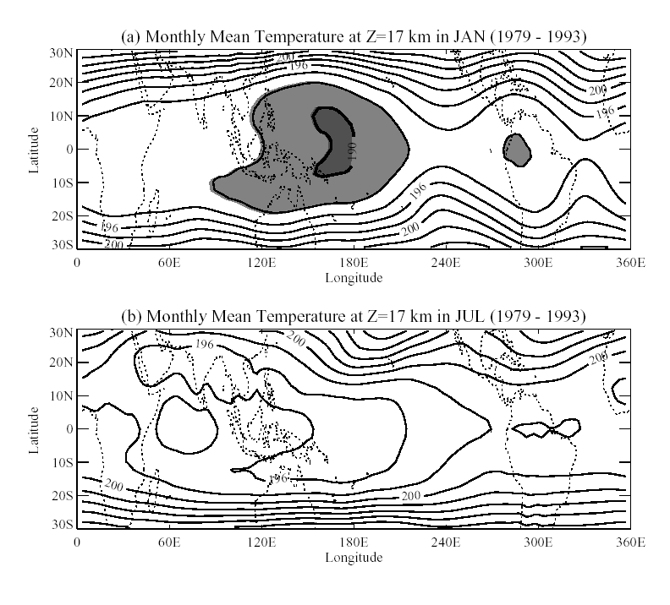

Fig. 1a, 1b
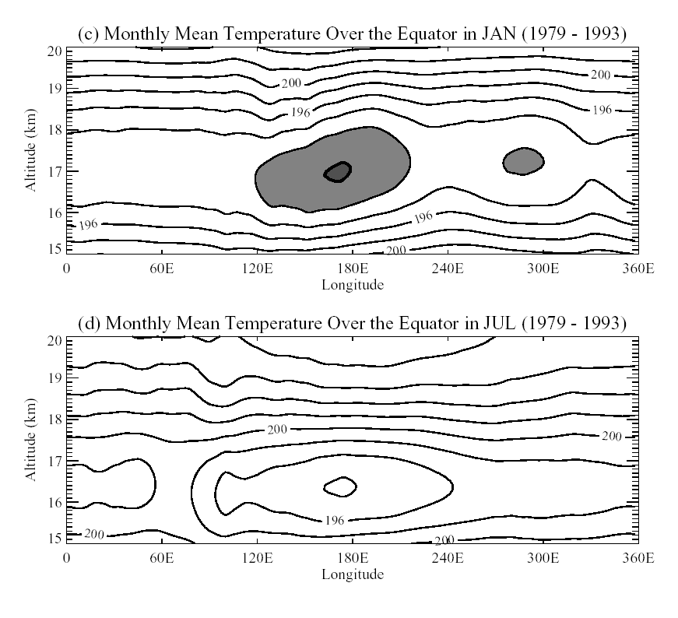

Fig. 1c, 1d

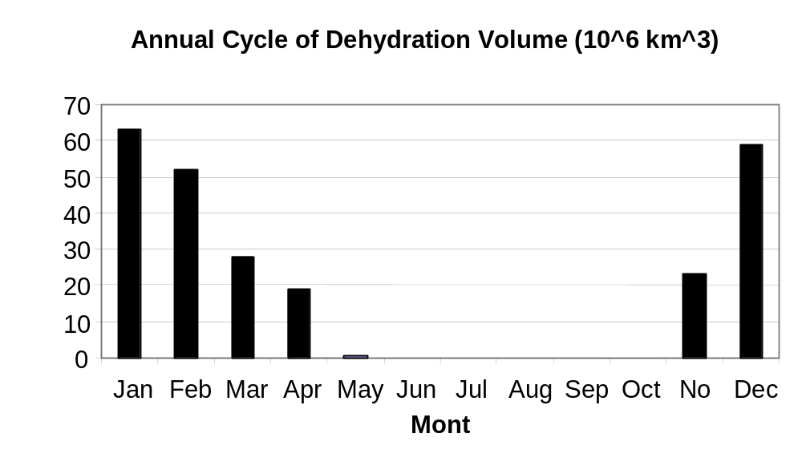

Figure 2.

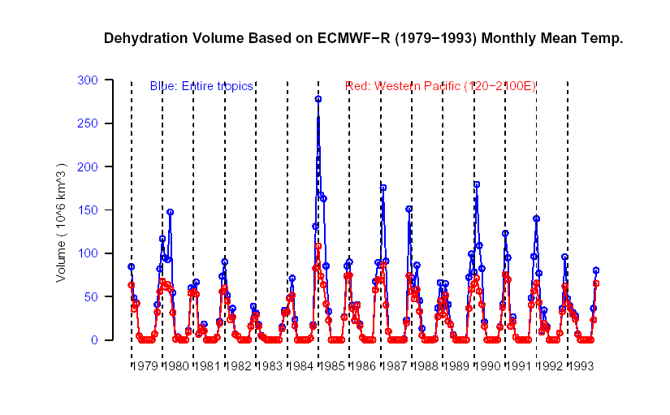

Fig. 3

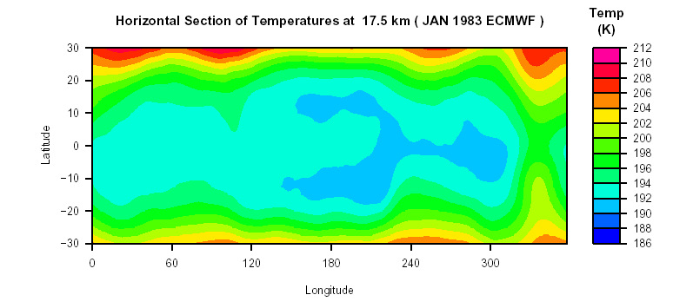

Fig 4a

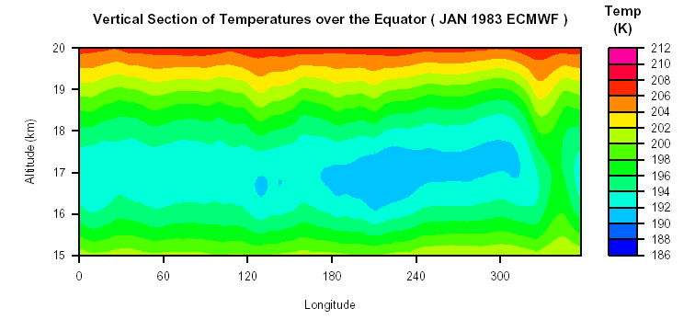

Fig 4b

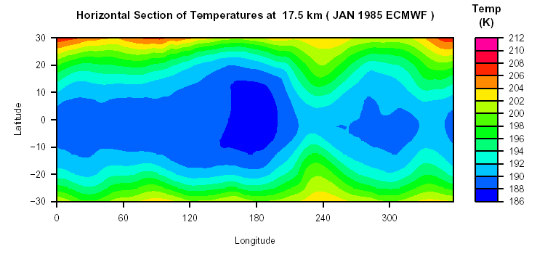

Fig 4c

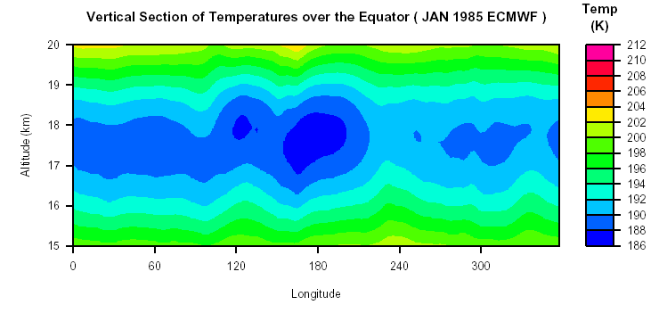

Fig 4d
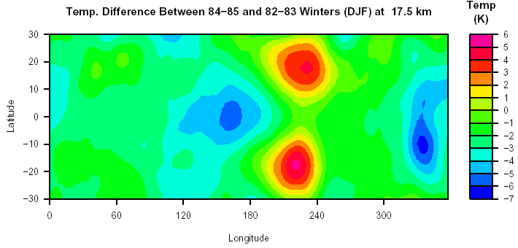

Fig 5a

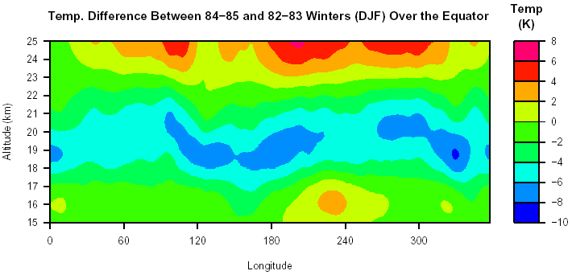

Fig 5b
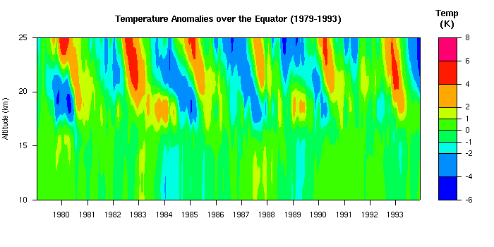

Fig 6

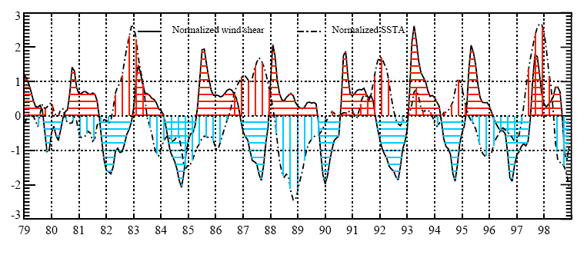

Fig 7

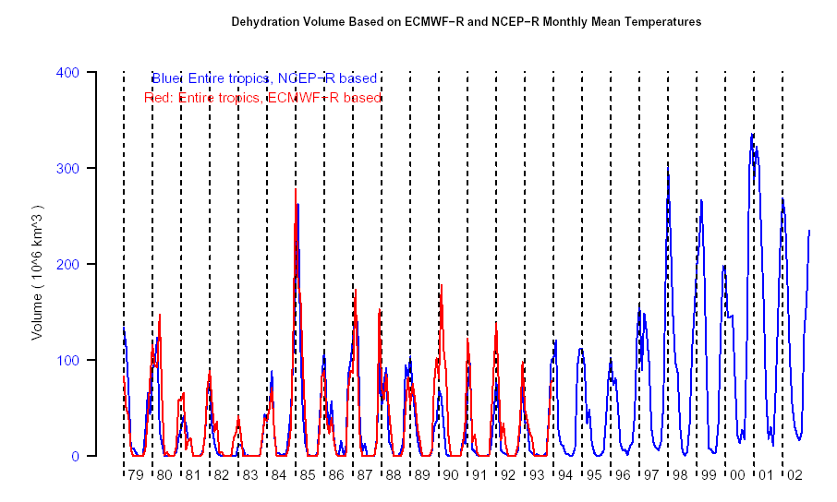

Fig 8

